QUICK SORT
1.
Quick Sort (Ascending Order Sorting)
Write a C++ program that sorts an array of integers in ascending order (smallest → largest) using the
Quick Sort algorithm. After sorting, print the sorted array.
Input Format
• First line contains an integer n (number of elements)
• Second line contains n space-separated integers
Output Format
• Print the sorted array in ascending order in one line.
• Must use Quick Sort logic (not built-in sort)
Input Output
6
11 15 7 5 19 6

5 6 7 11 15 19

#include<bits/stdc++.h>
using namespace std;
int partition (int A[],int l, int h){
int pivot= A[l];
int i= l;
int j= h;
while(i<j){
while(A[i]<= pivot){
i++;
}
while(A[j]>pivot){
j--;
}
if(i<j){
swap(A[i],A[j]);
}
}
swap(A[l],A[j]);
return j;

}
void quickSort(int A[],int l, int h){
if(l<h){
int j=partition(A,l,h);
quickSort(A,l,j-1);
quickSort(A,j+1,h);
}
}

int main(){
int n;
cin>>n;
int A[n];
cout<<"Enter array elements:";
for (int i=0;i<n;i++)
cin>> A[i];
quickSort(A,0,n-1);
for(int i=0;i<n;i++)
cout<<A[i]<< " ";
}

2.
Quick Sort in Descending Order
Write a C++ program that sorts an array using Quick Sort, but instead of sorting in ascending order, the
program must sort the array in descending order (largest → smallest). The program should print the final
sorted array.
Input Format
• First line contains an integer n = number of elements
• Second line contains n integers (array elements)
Output Format
• Print the sorted array in descending order in a single line.

#include<bits/stdc++.h>
using namespace std;
int partition (int A[],int l, int h){
int pivot= A[l];
int i= l;
int j= h;
while(i<j){
while(A[i]>= pivot){
i++;
}
while(A[j]<pivot){
j--;
}
if(i<j){
swap(A[i],A[j]);
}
}
swap(A[l],A[j]);
return j;

}
void quickSort(int A[],int l, int h){
if(l<h){
int j=partition(A,l,h);
quickSort(A,l,j-1);
quickSort(A,j+1,h);
}
}

int main(){
int n;
cin>>n;
int A[n];
cout<<"Enter array elements:";
for (int i=0;i<n;i++)
cin>> A[i];
quickSort(A,0,n-1);
for(int i=0;i<n;i++)
cout<<A[i]<< " ";
}

3.
Quick Sort with Swap Counter
Write a C++ program that sorts an array using the Quick Sort algorithm in descending order (largest →
smallest). After sorting, print the final array.
Input Format
• First line: integer n (number of elements)
• Second line: n space-separated integers
Output Format
• Print the array sorted in descending order in one line.

#include<bits/stdc++.h>
using namespace std;
int swapCount =0;
int partition (int A[],int l, int h){
int pivot= A[l];
int i= l;
int j= h;

while(i<j){
while(A[i]>= pivot){
i++;
}
while(A[j]<pivot){
j--;
}
if(i<j){
swap(A[i],A[j]);
swapCount++;
}
}
swap(A[l],A[j]);
swapCount++;
return j;

}
void quickSort(int A[],int l, int h){
if(l<h){
int j=partition(A,l,h);
quickSort(A,l,j-1);
quickSort(A,j+1,h);
}
}

int main(){
int n;
cin>>n;
int A[n];
cout<<"Enter array elements:";
for (int i=0;i<n;i++)
cin>> A[i];
quickSort(A,0,n-1);
for(int i=0;i<n;i++){
cout<<A[i]<< " ";
}
cout<< " Number of swaps:" << swapCount;
}

1. Write a program in C++ that sorts only the elements located at even indices (Example: 0, 2, 4, ...) of an array using the Quick Sort algorithm. The elements at odd indices must remain in their original positions.
Hint: Extract even-indexed elements, sort them using Quick Sort, then place them back in the same positions.

#include <bits/stdc++.h>
using namespace std;
int partition(int arr[], int low, int high) {
int pivot = arr[low];
int i = low;
int j = high;
while (i < j) {
while (i <= high && arr[i] <= pivot)
i++;
while (arr[j] > pivot)
j--;
if (i < j)
swap(arr[i], arr[j]);
}
swap(arr[low], arr[j]);
return j;
}
void quickSort(int arr[], int low, int high) {
if (low < high) {
int j = partition(arr, low, high);
quickSort(arr, low, j - 1);
quickSort(arr, j + 1, high);
}
}
int main() {
int n;
cin >> n;
int arr[n];
for (int i = 0; i < n; i++)
cin >> arr[i];
int evenCount = (n + 1) / 2;
int even[evenCount];
int k = 0;
for (int i = 0; i < n; i += 2)
even[k++] = arr[i];
quickSort(even, 0, evenCount - 1);
k = 0;
for (int i = 0; i < n; i += 2)
arr[i] = even[k++];
for (int i = 0; i < n; i++)
cout << arr[i] << " ";
}
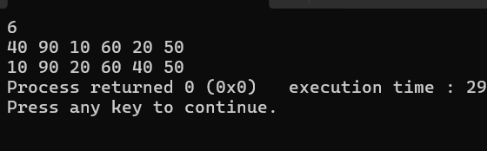

2. Write a program in C++ that sorts only the elements located at odd indices (Example: 1, 3, 5, ...) of an array using the Quick Sort algorithm. The elements at even indices must remain in their original positions.
#include <bits/stdc++.h>
using namespace std;
int partition(int arr[], int low, int high) {
int pivot = arr[low];
int i = low;
int j = high;
while (i < j) {
while (i <= high && arr[i] <= pivot)
i++;
while (arr[j] > pivot)
j--;
if (i < j)
swap(arr[i], arr[j]);
}
swap(arr[low], arr[j]);
return j;
}
void quickSort(int arr[], int low, int high) {
if (low < high) {
int j = partition(arr, low, high);
quickSort(arr, low, j - 1);
quickSort(arr, j + 1, high);
}
}
int main() {
int n;
cin >> n;
int arr[n];
for (int i = 0; i < n; i++)
cin >> arr[i];
int oddCount = n / 2;
int odd[oddCount];
int k = 0;
for (int i = 1; i < n; i += 2)
odd[k++] = arr[i];
quickSort(odd, 0, oddCount - 1);
k = 0;
for (int i = 1; i < n; i += 2)
arr[i] = odd[k++];
for (int i = 0; i < n; i++)
cout << arr[i] << " ";
}
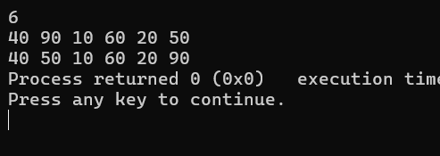

3. Write a program in C++ that performs Quick Sort on an array. After sorting, the program should display the sorted array and the frequency of each unique element.
#include <bits/stdc++.h>
using namespace std;

int partition(int arr[], int low, int high){
int pivot = arr[low];
int i = low;
int j = high;

while(i < j){
while(i <= high && arr[i] <= pivot){
i++;
}
while(arr[j] > pivot){
j--;
}
if(i < j){
swap(arr[i], arr[j]);
}
}
swap(arr[low], arr[j]);
return j;
}

void quickSort(int arr[], int low, int high){
if(low < high){
int j = partition(arr, low, high);
quickSort(arr, low, j - 1);
quickSort(arr, j + 1, high);
}
}

int main(){
int n;
cin >> n;
int arr[n];
for(int i = 0; i < n; i++){
cin >> arr[i];
}

quickSort(arr, 0, n - 1);

cout << "Sorted Array: ";
for(int i = 0; i < n; i++){
cout << arr[i] << " ";
}
cout << endl;

cout << "Frequency Count:" << endl;
int count = 1;
for(int i = 1; i <= n; i++){
if(i < n && arr[i] == arr[i - 1]){
count++;
} else {
cout << arr[i - 1] << " Occurred " << count << " times" << endl;
count = 1;
}
}
}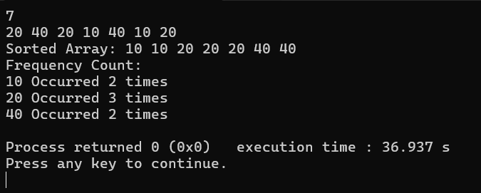

4. Write a program in C++ that sorts an array by the frequency of its elements. The elements with higher frequencies should come first. If two elements have the same frequency, they should be sorted in ascending order of their values.
Hint: You can count frequencies manually by iterating through the array, and then use the QuickSort algorithm to sort based on frequency and value.

#include <bits/stdc++.h>
using namespace std;
int PARTITION(int arr[], int low, int high)
{
int pivot = arr[low];
int i = low;
int j = high;

while (i < j)
{
while (arr[i] <= pivot)
{
i++;
}
while (arr[j] > pivot)
{
j--;
}
if (i < j)
{
int temp1 = arr[i];
arr[i] = arr[j];
arr[j] = temp1;
}
}
int temp1 = arr[low];
arr[low] = arr[j];
arr[j] = temp1;
return j;
}

void QUICK_SORT(int arr[], int low, int high)
{
if (low < high)
{
int pivot_index = PARTITION(arr, low, high);
QUICK_SORT(arr, low, pivot_index - 1);
QUICK_SORT(arr, pivot_index + 1, high);
}
}

int main()
{
int n;
cin >> n;
int arr[n];
for (int i = 0; i < n; i++)
{
cin >> arr[i];
}
QUICK_SORT(arr, 0, n - 1);
int m = 0, freq[n], num[n];
for (int i = 0; i < n; i++)
{
bool copied = false;
for (int j = 0; j < i; j++)
{
if (arr[i] == arr[j])
{
copied = true;
break;
}
}
if (copied == true)
{
continue;
}
num[m] = arr[i];
freq[m] = 0;
for (int k = 0; k < n; k++)
{
if (arr[i] == arr[k])
{
freq[m]++;
}
}
m++;
}

for (int i = 0; i < m - 1; i++)
{
for (int j = i + 1; j < m; j++)
{
if (freq[i] < freq[j] || (freq[i] == freq[j] && num[i] > num[j]))
{
int temp1 = freq[i];
freq[i] = freq[j];
freq[j] = temp1;

int temp2 = num[i];
num[i] = num[j];
num[j] = temp2;
}
}
}
for (int i = 0; i < m; i++)
{
for (int j = 0; j < freq[i]; j++)
{
cout << num[i] << " ";
}
}
cout << endl;

}

